Requirements and Specifications
Volume 3 - Algorithms
This document outline is based on the IEEE Standard 1058.1-1987 for Software Project Management Plans.
This is the controlling document for managing a software project, and it defines the technical and managerial processes necessary to deliver the project requirements.
The paragraphs written in the “Comment” style are for the benefit of the person writing the document and should be removed before the document is finalized.
For
PGSuper
Version 1.3
October 22, 1999
Richard Brice, PE
WSDOT
Richard Pickings, PE
BridgeSight Software
0000.doc
Revision Chart
This chart contains a history of this document’s revisions. The entries below are provided solely for purposes of illustration. Entries should be deleted until the revision they refer to has actually been created.
The document itself should be stored in revision control, and a brief description of each version should be entered in the revision control system. That brief description can be repeated in this section. Revisions do not need to be described elsewhere in the document except inasmuch as they explain the development plan itself.

Version | Primary Author(s) | Description of Version | Date Completed
1.1 - Final | RAB | First complete draft, which is placed under change control | 7/17/98
1.2 - Final | RAB | Update some of the analysis procedures | 3/9/99
1.3 | RAB | Updated equations for slab pad load and jacking stress | 10/22/99

Contents
New paragraphs formatted as Heading 1, Heading 2, and Heading 3 will be added to the table automatically. To update this table of contents in Microsoft Word, put the cursor anywhere in the table and press F9. If you want the table to be easy to maintain, do not change it manually.
1. Introduction 4
1.1 Document Organization 4
2. Mathematical Specifications 5
2.1 Girder Design 5
2.2 Girder Check 5
2.3 Structural Modeling 5
2.3.1 Casting Yard Stage 5
2.3.2 Bridge Site Stage 1 5
2.3.3 Bridge Site Stage 2 9
2.3.4 Bridge Site Stage 3 11
2.4 Locating the Critical Section For Shear 11
2.5 Maximum Allowable Jacking Force 12
2.5.1 Jacking Stress - First Edition 12
2.5.2 Jacking Stress - First Edition with 1996 and 1997 Interim Provisions 13
2.6 Deflections Due To Creep 13
2.7 Camber Calculations 13
2.7.1 Initial Camber 13
2.7.2 Total Camber 14
2.7.3 Screed Camber 14
2.7.4 Excess Camber 14
2.8 “A” Dimension Calculations 14
2.9 Moment Capacity Analysis 15
2.9.1 Equilibrium State 15
2.9.2 Strain in the Prestressing Steel 16

List of Figures
New figures that are given captions using the Caption paragraph style will be added to the table automatically. To update this table of contents in Microsoft Word, put the cursor anywhere in the table and press F9. If you want the table to be easy to maintain, do not change it manually.
This section can be deleted if the document contains no figures or if otherwise desired.
Figure 1 Casting Yard Stage Analysis Model
Figure 2 Bridge Site Stage 1 Analysis Model
Figure 3 End Diaphragm Load
Figure 4 Slab Cantilever Loads
Figure 5 Main Span Slab Load
Figure 6 Main Span Slab Pad Load
Figure 7 Intermediate Diaphragm Loads
Figure 8 Traffic Barrier Loads
Figure 9 Overlay Loads
Figure 10 Graphical Solution for Location of Critical Section for Shear
Figure 11 Strain Compatibility Method
Figure 12 Equilibrium State
Figure 13 Initial Strain in Prestressing Steel

Introduction
This section should describe the purpose and background of the project and the organization of this document. No text is necessary between the heading above and the heading below unless otherwise desired.

Document Organization
List all of the major sections of the document, symbols, etc.
This document is the third of a three volume set that defines the requirements and specifications for the PGSuper program. This volume contains detailed specifications for the analysis and design algorithms that are to be used by the PGSuper software. These specifications describe how the engineering problems associated with prestressed girders are to be solved.
The other volumes in this documentation set are Volume 1 - Requirements, which provides the detailed requirements for the PGSuper program, and Volume 2 - Specifications, which provides the detailed specifications for the PGSuper program.

Mathematical Specifications
This section describes formulas and algorithms used in implementing the computational functions of the system. For each major algorithm, provide an overview and a detailed description of the algorithm.

Girder Design
See “High Level Design Algorithm” flowchart.

Girder Check
See “High Level Check Algorithm” flowchart.

Structural Modeling
This section describes the analytical models used by PGSuper to object structural analysis results.

Casting Yard Stage
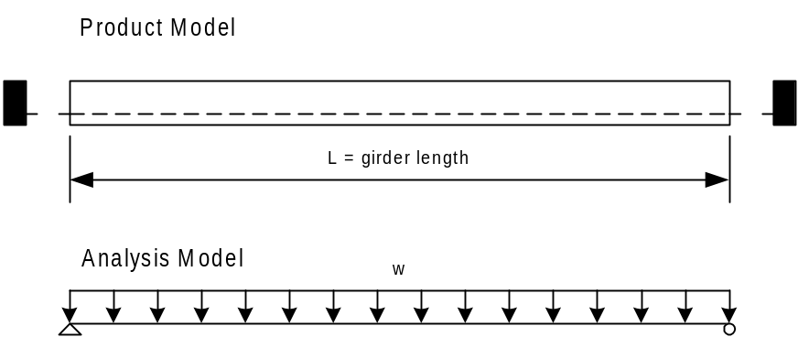
Figure 1 Casting Yard Stage Analysis Model
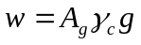, where
A_{g} | Gross cross sectional area of the girder
γ_{c} | Density of concrete
g | gravitational acceleration
Material properties for concrete are based on the release strength.

Bridge Site Stage 1
The concentrated loads P and M are the loads induced by the cantilever portion of the girder and the end diaphragms. Because PGSuper does not impose a restriction on the length of the overhangs or the size of the girders or diaphragms, the induced moments and reactions can be significant, therefore they will be modeled.
Material properties for concrete are based on the 28 day strength. It is assumed that all losses have occurred by this stage.
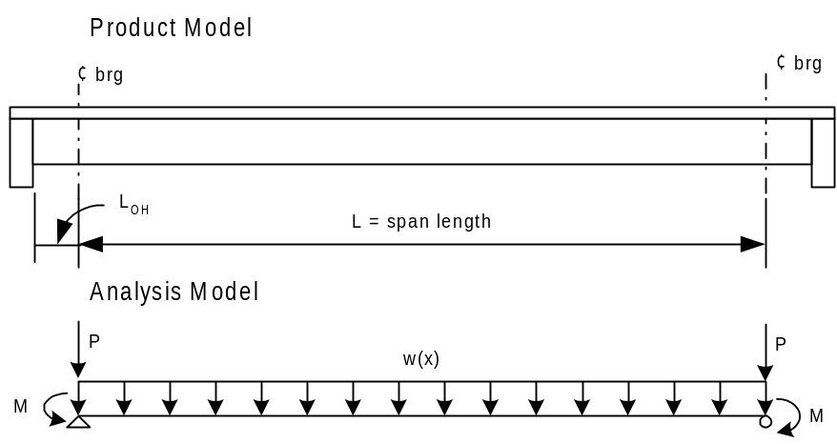
Figure 2 Bridge Site Stage 1 Analysis Model

Girder Cantilever Loads
The loads induced by the cantilever portion of the girder are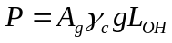, 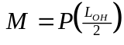

Diaphragm Cantilever Loads
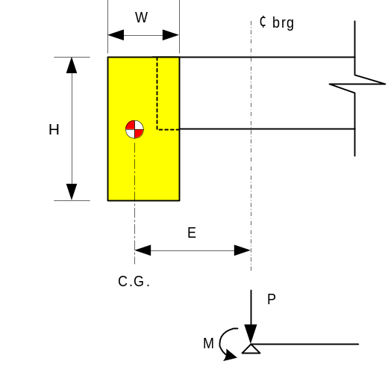
Figure 3 End Diaphragm Load
The loads induced by the diaphragms are 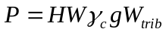, 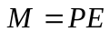, where
H | Height of end diaphragm
W | Width of end diaphragm
W_{trib} | Tributary width of the slab
E | Moment arm – Distance from C.G. of diaphragm to C.L. Bearing

Slab Cantilever Loads
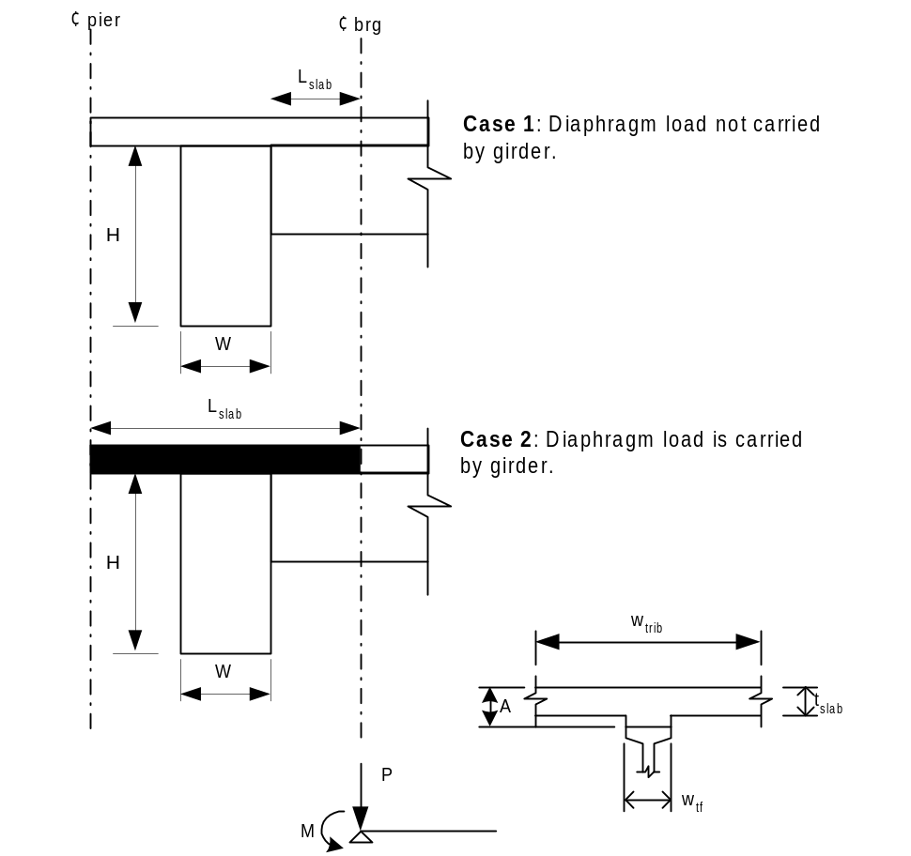
Figure 4 Slab Cantilever Loads
The loads induced by the cantilever portion of the slab are 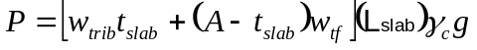, 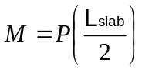.

Slab Load in Main Span
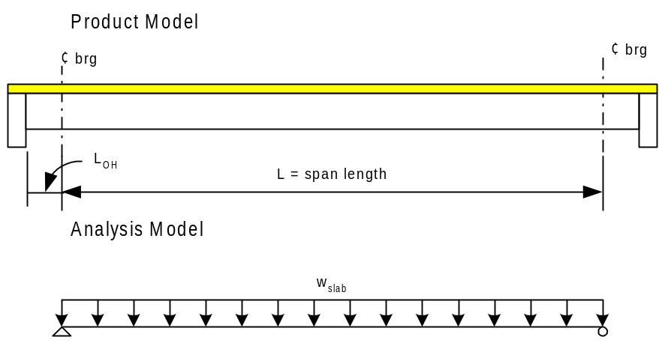
Figure 5 Main Span Slab Load
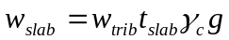

Slab Pad Load in Main Span
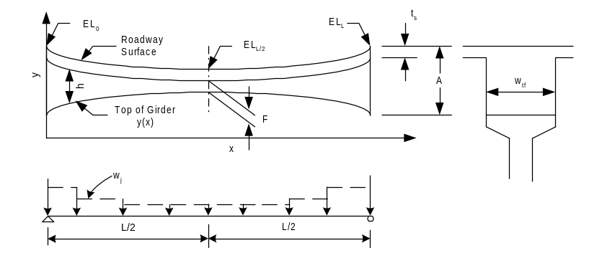The camber of the girder and the vertical curve form an hour glass shape. The top of girder is assumed to form a parabolic shape. The depth of the slab pad is A-t_{s} at the centerline of bearing and the fillet depth (F) at the centerline of span.

Figure 6 Main Span Slab Pad Load
The slab pad will be approximated with segments of uniform loads. The intensity of an individual segment of uniform load is,
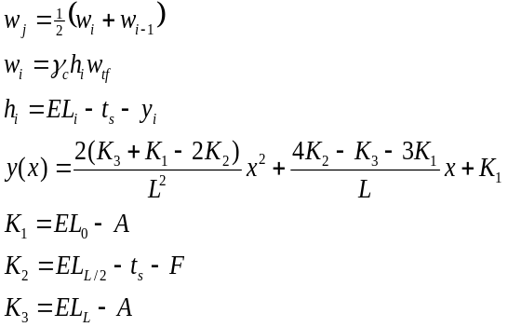

Intermediate Diaphragm Loads
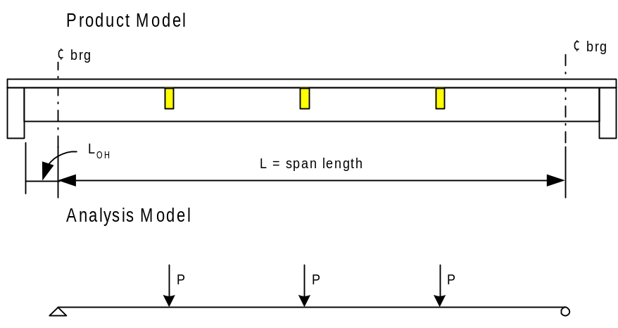
Figure 7 Intermediate Diaphragm Loads
For interior girders, 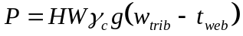 and for exterior girders 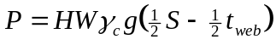, where
H | Height of the interior diaphragm
W | Width of the interior diaphragm
t_{web} | Width of the girder web
S | Spacing of the exterior girders

Bridge Site Stage 2
Superimposed dead loads are applied to the bridge in the stage 2 model. The superimposed dead loads consist of the traffic barrier and the overlay.

Traffic Barrier Load
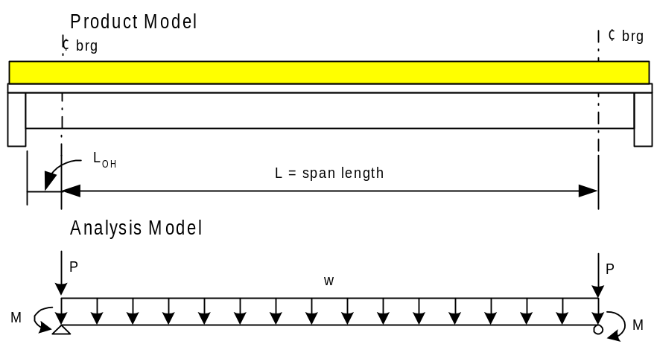
Figure 8 Traffic Barrier Loads
The basic traffic barrier load is 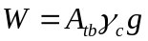. The traffic barrier load is distributed over n exterior girders, if there are 2n or more girders, otherwise the weight of the traffic barrier per girders is 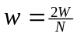, where N is the number of girders in the span. The cantilever portions of the load are 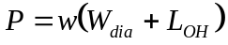 and 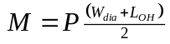.

Overlay Load
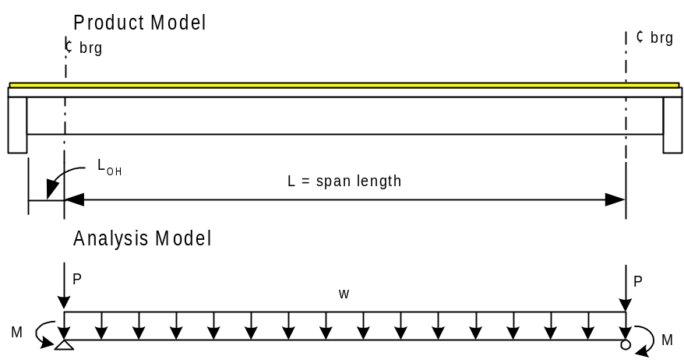
Figure 9 Overlay Loads
The overlay load in the main span is 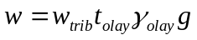, where
w_{trib} | Tributary width of the slab. For exterior girders, the portion of the traffic barrier that sits on the slab shall be deducted from this amount.
T_{olay} | Depth of the overlay
γ_{olay} | Density of the overlay
The cantilever portions of the load are and .

Bridge Site Stage 3
The live load is applied to stage 3. The HL93 live load model will be used and applied between the centerlines of bearings.

Locating the Critical Section For Shear
The LRFD Specification has made the determination of the critical section for shear a daunting calculation. This Section provides a discussion of the requirements, and possible assumptions for an algorithm to determine this location.
Article 5.8.3.2 states that the critical section for shear may be taken as the larger of d_{v} or 0.5d_{v}cotθ. The LRFD Specification does not provide any information as to where d_{v} and θ are to be taken. WSDOT believes it should be at the location of the critical section. This makes the determination of the critical section for shear an iterative process since, d_{v} and θ vary based on location and limit state.
A conceptual algorithm for locating the critical section is as follows:
1. Guess the location of the critical section X.
2. Evaluate X1 = dv(X)
3. Evaluate X2 = 0.5dv(X)cot(θ(X))
4. Check guess. If X != Max(X1,X2), go to step 1.
Repeat for each limit state used for shear design.

A graphical solution would look as follows:
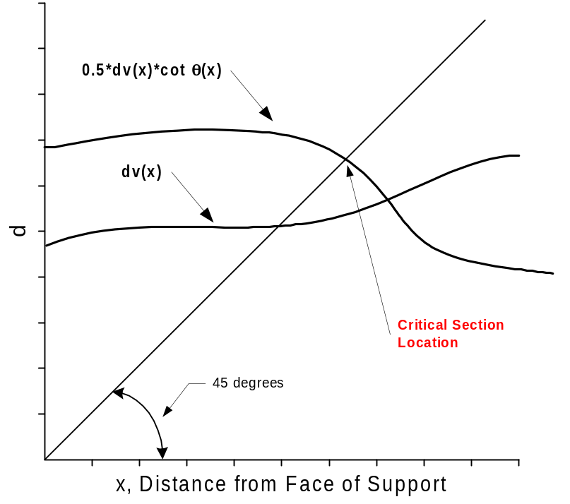
Figure 10 Graphical Solution for Location of Critical Section for Shear
Although accurate and true to the Specifications, this method is impractical because of the large computational cost of calculating force envelopes at each guessed location in order to determine θ(X) (a complete live load analysis would have to be run for every point). However, examination of many d_{v} and θ graphs reveals that their shape is well-behaved. Hence, it should be practical to approximate the d_{v} and θ near the support. The control points used to create the curves will be at the 0.00, 0.05, and 0.10 points along the girder. It is believed that the critical section for shear should always fall within this range. A numerical algorithm, such as Brent’s method or bisection method, will be used to find the approximate location of the critical section.

Maximum Allowable Jacking Force
This section describes how to compute jacking forces for prestressing strands.
The jacking force is computed as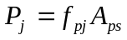where f_{pj} is the jacking stress and A_{ps} is the total area of prestressing strand.

Jacking Stress - First Edition
The jacking stress is prescribed in Article 5.9.3 of the 1st Edition of the LRFD specification. The jacking stresses are
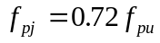 for Stress Relieved Strands
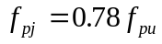 for Low Relaxation Strands

Jacking Stress - First Edition with 1996 and 1997 Interim Provisions
The 1st Edition with 1996 and 1997 interim provisions change the method by which the allowable jacking stress is to be computed. Article 5.9.3 specifics the strand stress immediately prior to prestress transfer as
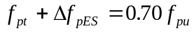 for Stress Relieved Strands
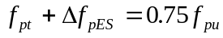 for Low Relaxation Strands
The jacking stress is 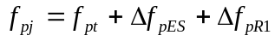.
Substituting, we get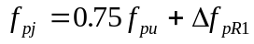. Note: From now on, we will only deal with the stress relieved strands. The formulation for low relaxation strands is similar.
From LRFD Equation 5.9.5.4.4b-1, 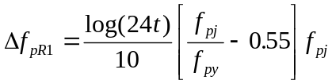
Substituting and re-arranging, we get
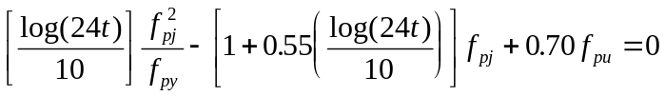This equation is solved for f_{pj.}

Deflections Due To Creep
Deflections due to creep are computed in accordance with Article 5.4.2.3 of the LRFD Specification. The deflection due to creep is taken as 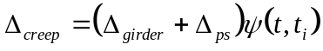. If the concrete is cured by steam or radian heat, t_{i} will be taken equal to seven days of normal curing for each day of accelerated curing.

Camber Calculations
Several elements make up the camber calculations. Each one is detailed in this section. Refer to Section 6.3.1c of the BDM for further discussion of camber.

Initial Camber
Initial camber occurs when the prestressing strands are release in the casting yard and the eccentric prestress force is imposed on the section. The beam has material properties associated with the release strength of the concrete and the span length is equal to the length of the girder. Immediately after release, the girders are removed from the casting bed and placed in storage until the concrete reaches it 28 day strength. During storage it is assumed that the girder is supported at the location of its final bearing points. During storage, the span length is less then the span length in the casting yard. The initial camber will take this into account.
The initial camber is computed as 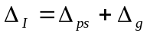, where
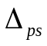 | deflection due to prestressing measured relative to the girders final supports. 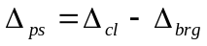, 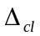is the deflection at the centerline of the span and 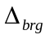is the deflection at the final bearing point when the girder length is used as the span length.
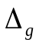 | deflection due to the self weight of the girder, using the final span length

Total Camber
Total camber is equal to 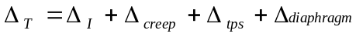, where
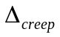 | deflection due to creep.
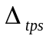 | deflection caused by the removal of temporary prestressing strands used to control camber, stability, and release strength
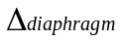 | deflection due to casting of diaphragms
The deflection caused by the removal of temporary prestressing strands is computed using the span length of the girder in its final configuration and material properties associated with the 28 day concrete strength.

Screed Camber
Screed cambers is equal to the amount the girder will deflect when the wet slab is placed. This is the amount screeds must be cambered by so the correct finished roadway surface is achieved. The screed camber is computed as 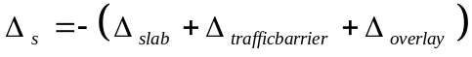.

Excess Camber
The excess camber is the amount of camber remaining in the girder after the diaphragms and roadway slab are placed. The excess camber is computed as 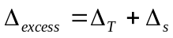.

“A” Dimension Calculations
The “A” dimension is the distance from the top of the girder to the top of the roadway slab measured at the centerline of the pier. The basic idea of the “A” dimension is to have the top of the girder not higher than the bottom of the slab plus a fillet dimension at the centerline of the span. The components of the “A” dimension calculation are described below. Note that these equations are unit independent and only require that consistent units be used. See page 6.1-A1-1 of the BDM for more information
where,
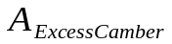 | Excess girder camber, 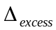
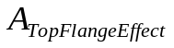 | Top flange width effect, 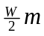, where W is the width of the top flange and m is the deck crown or super elevation slope.
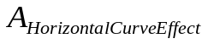 | Horizontal Curve Effect, 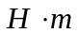, where 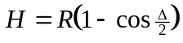, where R is the radius of the curve passing through the centerline girder - centerline bearing intersection points of the girder under consideration.
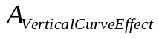 | Vertical Curve Effect, 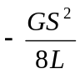, where G is the algebraic difference in profile tangent grades (%), S is the span length, and L is the length of the vertical curve.

Moment Capacity Analysis
Moment capacity is computing using a strain compatibility methodology. A Modified-Whitney stress block is used in lieu of a material model for the concrete. The Modified-Whitney method is new to the LRFD specification. It is also known as the Naaman method. An elastic-perfectly plastic material model is used for mild steel reinforcing. The material model for low relaxation and stress relieved prestressing reinforcement is taken from section 2.11 of the PCI Bridge Design Manual.
Ultimate moment capacity is computed relative to zero strain in the cross section. Figure 11 illustrates the high level procedure.
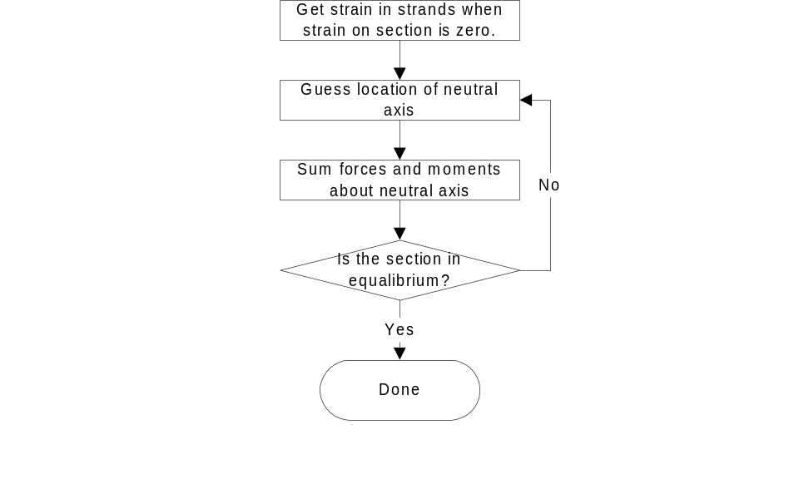
Figure 11 Strain Compatibility Method

Equilibrium State
Figure 12 shows the equilibrium state from which the nominal moment capacity is obtained.
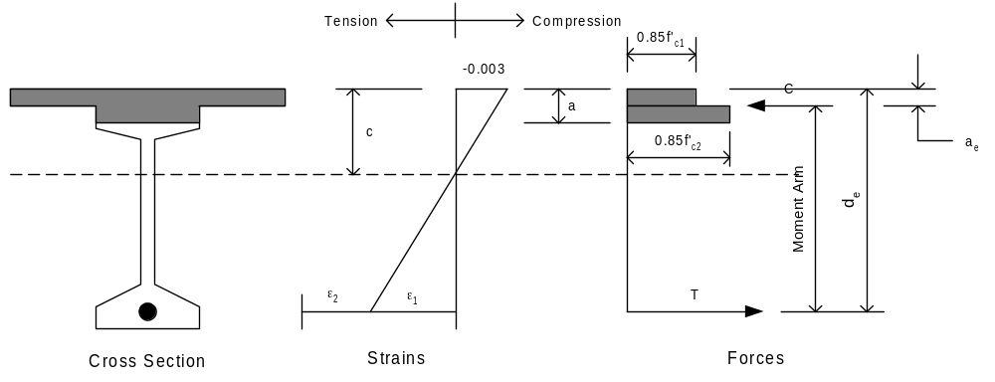
Figure 12 Equilibrium State
The strain ε₂ is the strain in the prestressing steel relative to zero strain in the cross section. The strain ε₁ is the strain associated with the flexure of the cross section. The area of the cross section in compression is taken to be β₁ times the area on the compression side of the neutral axis. The resultant compressive force, C, acts at the centroid of the compression area.

Value of β₁ for Composite Sections
In composite construction, the stress block factor, β_{1,} may be different for different components of the compression block. In this case, an average value of β₁ for composite sections is taken from section 8.2.2.5 of the PCI Bridge Design Manual as:
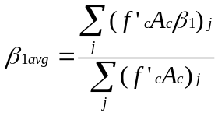

Strain in the Prestressing Steel
The strain in the prestressing steel, relative to an unstrained cross section is computed by the following procedure.
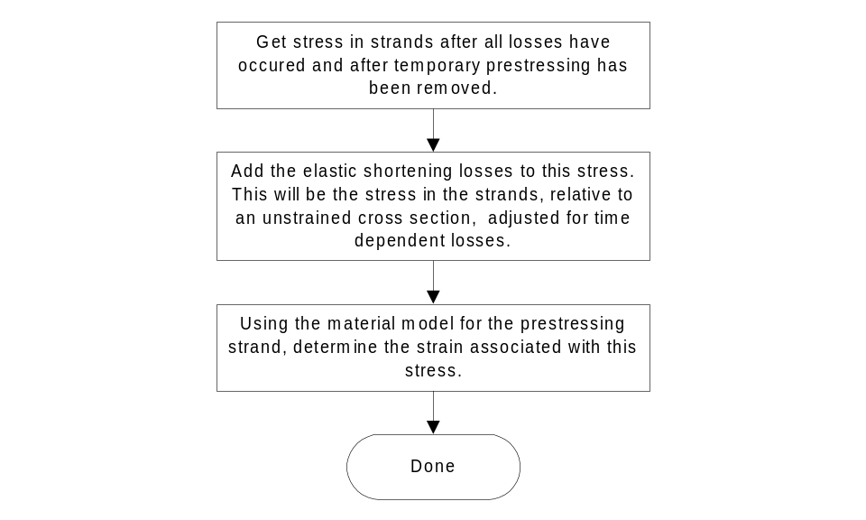
Figure 13 Initial Strain in Prestressing Steel

